The First Announcement
__________________________________________
The 2nd International Symposium on Lithium Applications for Fusion Devices

April 27 - 29, 2011
Princeton, New Jersey, USA
_____________________________________________________________
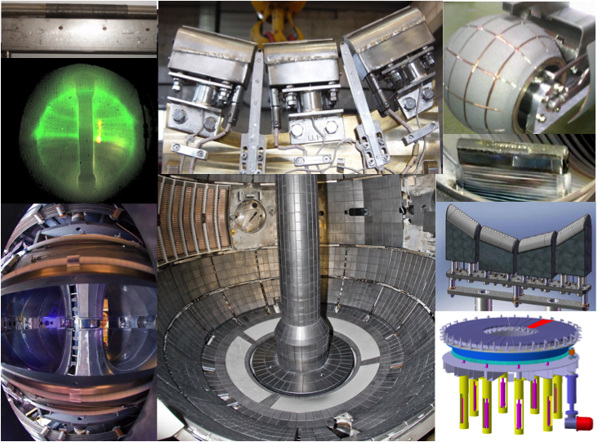

Dear colleagues,

We invite you to attend the 2nd International Symposium on Lithium Applications for Fusion Devices which will be held on April 27 – 29, 2011 at Princeton Plasma Physics Laboratory, Princeton, New Jersey, USA. The purpose of this symposium is to bring together scientists and engineers actively engaged in research on lithium applications for fusion devices so that recent progress and issues can be discussed in an open forum for the eventual development of attractive fusion reactors.
This symposium will include sessions for:
1. Lithium effects on edge and core plasma properties in magnetic confinement devices;
2. Laboratory experiments on plasma-lithium interactions;
3. Technologies for handling solid, liquid and vapor lithium; and
4. Other lithium-related subjects.
A special session is planned on the development of technologies of lithium applications for fusion reactors.
Those who wish to make presentations on a pertinent topic for the symposium are requested to submit by e-mail (mono@pppl.gov) a one-page abstract of the proposed presentation by December 15, 2010. Abstracts received by this date will be considered for either an invited or contributed presentation by the Program Committee. Abstracts received after December 15, 2010 but before January 31, 2011 will be only considered for contributed presentations.

If you wish to attend the symposium without making a presentation, please indicate your interest to the organizers by e-mail (mono@pppl.gov) so that we can include you in future correspondence. If your visit to PPPL would require a US visa, please let us know as soon as possible before Dec. 15, 2010 so that we have a sufficient time to process an invitation letter for your visa application.

Proceedings: Papers submitted to this symposium will be published after peer review in a special issue of a widely-circulated journal (Fusion Engineering and Design is currently under consideration)

Please forward this mail to colleagues who might also be interested in this symposium on lithium.

We look forward to seeing you in Princeton in April 2011.

Local organizing committee: M. Ono, M. G. Bell, R. Kaita, H. W. Kugel, C. H. Skinner, J. E. Menard
International Program committee: Y. Hirooka (Japan), S.V. Mirnov (Russia), G. Mazzitelli (Italy), M. Ono (Chair, USA), F.L. Tabares (Spain) and M. Shimada (France)

